1. **School bussing problem, revisited**

Recall the student bussing problem of HW1 from BAMS 506. The case you read for that assignment appears in the Miscellaneous folder of the BAMS 508 Canvas site (“School Assignment Case”).

1. The problem is about assigning students to schools. As discussed in BAMS 508, “the

Assignment Problem” is one example of a “Minimum Cost Network Flow” problem, for which integer supply and demand constraints automatically leads to integer-optimal solutions (without telling the optimization software that flow variables must be integer). Since the home areas each have integer number of students, and the schools each have integer capacity, should your solution to the problem of part (b) of the case automatically be integer? If so, explain why, if not, explain why not.

That version of the problem did not consider the cost of acquiring busses, nor their capacities. Now suppose the following extension of the problem. Each bus costs $40,000 to acquire and can carry a maximum of 60 students.

1. How would your formulation of part (a) be updated?
2. What is the new solution?
3. With BAMS 508 concepts and tools, you can now also update your formulation to handle the extension discussed in part (d) of the case. How?
4. What is the new solution? (building off of the formulation/solution from parts b and c)
5. **Burrito Optimization Game, revisited**

If you go to Round 1, Day 1, of regular play mode and click on the download box in the upper-right corner, you will obtain four .csv files, which I have put in the Miscellaneous folder.

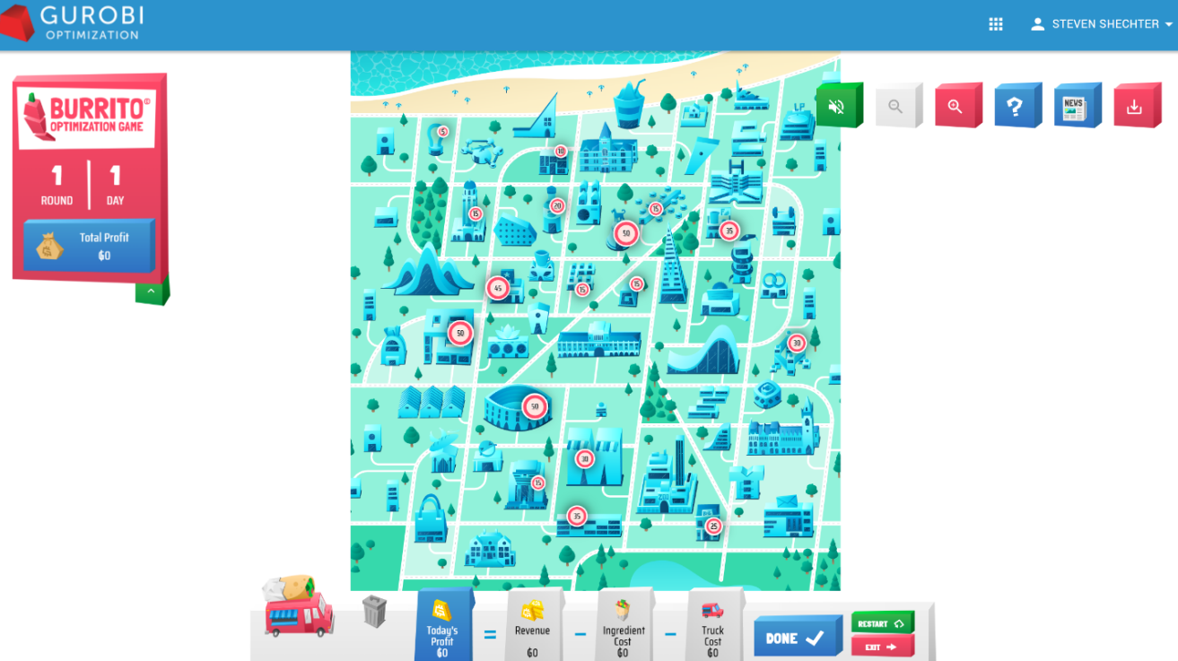

The information contained in these files is summarized as follows:

* problem_data.csv: gives the cost and revenue parameters for the day
* demand_node_data.csv: gives the x,y coordinates of the buildings and their total demand
* truck_node_data.csv: gives the x,y coordinates of all the possible locations where you can place the trucks
* demand_truck_data.csv: gives the distances between each building and each possible truck location, along with the scaled demand (i.e., the values of $α_{ij}d_{i}$ from the IP formulation in the middle of [this page](https://www.gurobi.com/burrito-optimization-game-guide/)).

1. Estimate a function, f(*d*), that provides a good fit for predicting the fraction of total demand that will travel a distance of *d* for a burrito (i.e., that can be used to estimate $α_{ij}$ based on the distance between i and j). Justify your answer.
2. Using some of the information contained in the files provided, set up and solve the optimization problem. Check that you get the same solution given by Gurobi when you click on “Done” on Day 1, Round 1 of the game.
3. Suppose that trucks have limited supplies and that each truck can serve a maximum of 30 customers per day. Assume you can have multiple trucks located at the same spot (close enough in front of one another that we’ll use the same distances and scaled demand between buildings and that truck location). Also assume that if customers from a building cannot be served by the closest truck (due to its capacity constraint), then they will walk to the second-closest truck, and so on. Explain what needs to change in the formulation of this version of the problem compared to that in part b. Then solve the new version of the model, and provide managerial discussion/insights for comparing the solutions of parts b) and c).